South Sound Critter Care 
Approved_______ Denied__________
Date:

Pick-up Date/Time:_______________________
28727 216th Ave Se
Kent, Wa 98042
P: 360-886-8000
F: 360-886-2591

FOR OFFICE USE ONLY:
Interviewed by: _______________
Animal I.D#: __________________

Feline Adoption Application:
Disclaimer: South Sound Critter Care reserves the right to refuse adoption to anyone who fails to comply with South Sound Critter Care’s policies. FAILURE TO PROVIDE ALL CORRECT INFORMATION MAY WARRANT ADOPTION DENIAL.

Date: _____/_____/_____

Name: _____________________________________________________________________
Last First Middle

Spouse/Roommate: _____________________________________________________________________
(Circle one if applicable) Last First Middle

Address: _____________________________________________________________________
Street City State Zip Code/County

Cell Phone: (_____) ______-_______ Home Phone: (_____) ______-______

Email: ________________________________________________________________
*Required if you would like to take advantage of 30 days free Pet Insurance*

Occupation: ____________________________________

1) Is this your first experience owning a cat? YES / NO (circle one)
Please list any pets you’ve owned in the last 10 years. If you have re-homed a pet or had one pass away, still list them.

Name Species Years Owned Altered(Y/N)? Age? Kept Where?

2) Have you ever adopted from us in the past? YES/NO (circle one)
If yes, when? _________________________________________

3) You want to adopt a cat for: (circle one) A house pet/ A child/ A gift
A mouser, barn cat/ companion
Sibling for another pet/ other: _____________

4) Where will you cat live? (circle one) Indoors Only/ Outdoors Only/ Both

5) We require that all cats adopted from South Sound Critter Care MUST be spayed or neutered. Do you have any questions or reservations about this requirement? YES/ NO (circle one)
If yes please explain: ____________________________________________

6) How do you feel about de-clawing? ________________________________________

7) Are you prepared to meet the financial responsibility of owning a pet? An average cost of $300.00 to $500.00 per pet, per year. YES/NO (circle one)

8) If the cat is in need of additional care or vaccinations, do you plan on bring him/her back for additional treatment, etc, at your cost? YES/NO (circle one)

9) Who is your regular veterinarian? Clinic name and location: _________________ Phone Number: _____________________

10) Is this pet going to be living with you? YES/NO (circle one)
If not, with whom? ________________________________

11) How many people live in the household? ___________________________________
What are the ages of any children in your household? ____________________________

12) Do all the adults in the home know of your plan to adopt a cat? YES/ NO (circle one)

13) Does anyone in the home have any known allergies to animals? YES/NO (circle one)
If so, what kind of animals? ____________________________________________

14) What adult(s) will be responsible for the care of this cat? _____________________________________________________________________

15) Where will this cat be kept during the Day? ___________ Night?________________
When alone? ___________________

16) Are you familiar with the FeLV and FIV virus? YES /NO (circle one)

17) Are you familiar and/or interested in pet insurance? YES/ NO (circle one)

18? Please give 1 reference OTHER than your Veterinarian or immediate family member (include name, phone number, address, and relationship) ______________________________________________________________

______________________________________________________________

Questions to ask references

For Veterinarians:
- Do they take their pet(s) to your clinic regularly? __________________________
- Are their pet(s) up-to-date on vaccines? _________________________________
- Has their pet(s) had any major accidents? ________________________________

For Other Reference:
- How does the adopter interact with your pets? _____________________________
- Has the adopter ever yelled at or hit their pet(s)? ___________________________
- How many pet(s) has the adopter owned that you know of? __________________________________________________________________
- Other comments: ____________________________________________________________________________________________________________________________________

Interviewers notes: ________________________________________________________________________________________________________________________________________________________________________________________________________________________________________________________________________________________________________________________________________________________________________________________________________________________________________________

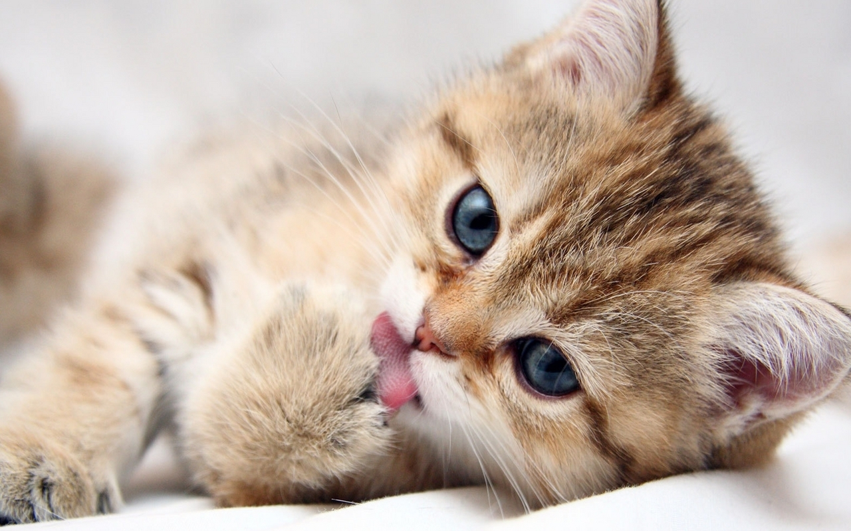

Kitten Adoption is $355.98. This includes the preventative services the cat will need in his /her first year .

First initial Doctor Exam
Felv/FIV testing (feline AIDs & Leukemia)

2-3 rounds of de-worming treatment
Drontal- Pyrantel- Revolution

2-3 rounds of flea control
Frontline- Revolution

All vaccines, including booster shots
3 Fvrcp- 2 Felv- 1 Rabies

2 Toe nail trims

Microchip (24 hour)

30 Days of Free Pet Insurance

10% off Spay or Neuter when old enough-usually done before adoption

All proceeds go to our Non- Profit Puget Sound Wild Care facility

